Player protection Policy

Glenrothes Strollers (the club) is fully committed to protecting the welfare of all players in its care. It recognises the
responsibility to promote safe practice and protect players from harm, abuse and exploitation, whilst providing fun for all.
This policy outlines Glenrothes Strollers commitment to protect players.
and is based on the following

player’s rights

- The rights to a safe environment

- not to be discriminated against;

- protection against harm or the risk of harm;

- protection against all forms of abuse including physical, verbal, emotional, sexual, neglect and bullying
- express opinions and to have those opinions considered in all matters that concern their wellbeing

- all actions concerning the child will be in his/her best interests

- have all suspicions and allegations taken seriously and actioned as appropriate

Glenrothes Strollers will:
- Promote the health and wellbeing of children by providing opportunities for them to take part in grassroots football safely
- Respect and promote the rights, wishes and feelings of players

- Promote and implement appropriate guidelines to protect the welfare of players.

- Recruit, train, support and supervise its staff and officials to adopt best practice to protect players from abuse and to reduce risk to themselves

- Ensure all staff and registered officials know that they have a responsibility to keep children safe

- Ensure staff and officials adopt and abide by this Player Protection Policy and Procedures

- Respond to any allegations of misconduct or abuse of players in line with this Policy and procedures and implement, where appropriate, the relevant disciplinary and appeals procedures

- Regularly monitor and evaluate the implementation of this Policy and procedures

- Annually review this policy to ensure it is kept up to date with changes in legislation;

- Ensure that all staff, registered officials and volunteers are PVG registered.

Glenrothes Strollers will ensure that:

- They appoint Club Officials to undertake the responsibilities as previously listed and they are registered with the SYFA and PVG scheme.
- The club takes all steps, to protect all players and officials from abuse, harm or the risk of harm during all football activities
- Immediate notification is made to the SYFA in writing if any official is charged with any criminal offence

- They appoint a Protection Officer and ensure they undertake the Protection Officer Training

- This will ensure a single point of contact for anyone with concerns about a player, a consistency of response to any concerns, secure handling of information and co-ordination of referrals to other agencies.

- Ensure all coaches undertake online child protection course

- All club officials are PVG checked.

- That club members, players and players’ parents/guardians are advised of who the club Protection Officer is.

- The club is committed to eradicating bad practice and to implement all proposals or amendments in respect of player protection policies.

- In cases of reported abuse, maintain total confidentiality as guided by the Club Protection Officer.

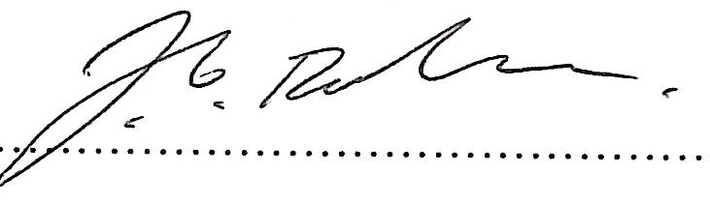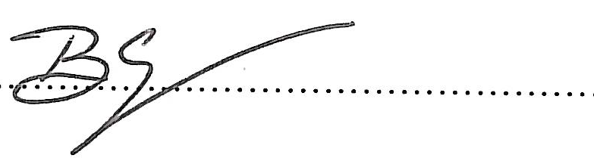

version 1.1 reviewed July 2017

